CIS 3020 Progress Report
Jose Villeda
Week 6
Project name: Billing Dashboard for an Independent Language School
Brief description and its purpose: A dashboard that allows students to access information related to their course content but mostly focused on handling billing transactions such as requesting statements.
Target users: Language learners that attend the school.
Current Project Status
o What is implemented and working: Login form that submits a POST request into a backend server and creates a user session.
o What is partially implemented: User verification, the website will let the user know if credentials are invalid, but not all cases are implemented yet.
o What is not started yet: Password hashing, real database, class content, billing related features.
What Has Gone Well
o Tools or concepts that were easier than expected: Sending POST requests to a backend, I always thought it would be more complex to handle but, in the end, it was indeed somewhat confusing, but I managed to understand it.
o Features or tasks completed successfully: Redirection when user credentials are submitted correctly and denying access to private files without authentication.
Challenges and Problem Solving
o Technical or conceptual difficulties: JavaScript syntax and Node.js/Express.js functions. It was considerably hard to understand the syntax of features such as arrow functions, especially because it was very common to nest function inside functions. Regarding Node and Express, it was challenging not knowing the methods that are implemented within these frameworks since there are many of them that are essential to build basic request handling functions.
o How you attempted to solve them: Watching diverse tutorials, reading about the framework and debugging such as console logging the functions that I didn’t understand, to have a clearer picture of what they output.
o What you learned from the process: I learned that using external resources is common and necessary when working on a project, as well as being patient, given that most of the time, complex issues that appeared tedious and hard to resolve, ended up having simpler solutions that could have been harder in the absence of patience.
• Next Steps
o Specific tasks planned before the next checkpoint: Improving user validation features, as well as providing better feedback with the use of status codes and error messages.
o Short-term development goals: Improving the style aspect of the website in order to work on having a better visual base for the project. Improving the mock-database or moving it into a real database. Implement hashing.
• Resources and Tools Used
o Tutorials, websites, documentation:
- Anson the Developer’s Express.js Tutorial Playlist: Express JS Full Tutorial Playlist 2024 - YouTube
- Express.js official documentation
- Varied Youtube tutorials for specific topics
o AI tools (if used) : Visual Studio Code’s AI feature to generate commit messages to GitHub.
o Other people or sources of help: n/a
• Generative AI Use (If Applicable):
- ChatGPT
- Google search automated AI responses
o What you used AI for: AI was used almost completely as a personal teacher, a chatbot that would answer specific questions that would otherwise take days to get resolved in forums such as Stack Overflow. If any code was generated to resolve my questions, I would ask more questions and also watch tutorials about the matter to make sure that I understood the code or solution provided by AI. Worth noting that not a single line of code was copied from AI to paste it into the project, but rather I saw it in Anson’s playlist ad typed it along the tutorial while he explained it.
o What you did yourself: Render deployment troubleshooting that not even AI was able to solve for me, HTML was 100% built by me, and some less common CSS features were proposed and explained to me by ChatGPT such as grid area assignments, in every case where something more advanced was implemented, it was always followed by a tutorial video.
o Screenshots of prompts used (included as images or appendix)

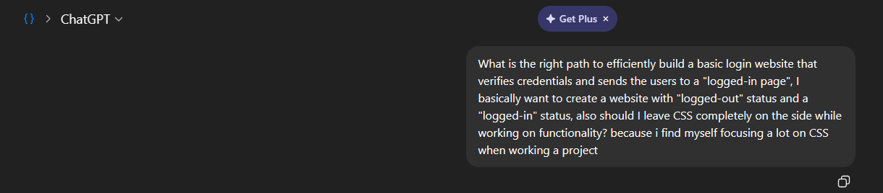
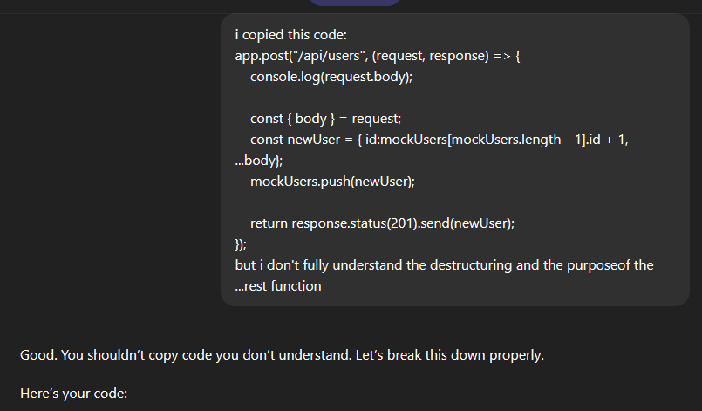

• Links
o GitHub repository:
https://github.com/marinimaster/cis3020project/settings/pages
o Live site (if applicable):
https://marinimaster.github.io/cis3020project/
o Any relevant demos or documentation: Windows subsystem for Linux was an essential tool to install features like nodemon, Node and Express.

